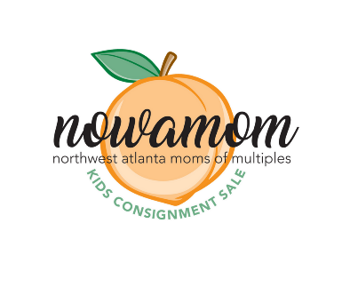
Spring/Summer 2020
Sponsor Online!
http://nowamom.org/event-3732438

NOWAMOM Kids Consignment Sale
March 13th-14th, 2020
Sandy Plains Baptist Church
Sponsorship Levels
Platinum On-Site Sponsor $150 Only 3 slots available!
- Exclusive 6 ft Table Space during Preview Sale Friday night (6pm-9pm) and Public Sale Saturday, March 9th (8am – 2pm). Set up a display to attract and interact with potential new clients. Must have Cobb County business license to sell any items. No homemade items.
- Include a promo item in our Swag bags! Include your business card, a flyer, magnet, coupon, or promotional item in Swag bags given to customers. We expect at least 450+ customers at our sale!
- Your business logo with website link will be advertised on www.nowamom.org and www.NowamomSale.org.
- Your business logo with website link will be included in several email blasts. We have over 800 local subscribers.
- Social Media Exposure
  - Star in a Facebook Live video during the sale to fans of the NOWAMOM Kids Consignment Sale page. We have over 1300 followers! We will also do Instagram Live videos.
Gold Sponsor $75
- Include a promo item in our Swag bags! Include your business card, a flyer, magnet, coupon, or promotional item in Swag bags given to customers. We expect at least 450+ customers at our sale!
- Your business logo with website link will be advertised on www.nowamom.org and www.NowamomSale.org.
- Your business logo with website link will be included in several email blasts. We have over 900 local subscribers.

Silver Sponsor $50
- Include a promo item in our Swag bags! Include your business card, a flyer, magnet, coupon, or promotional item in Swag bags given to customers. We expect at least 450+ customers at our sale!

